Enhancing Parent Involvement in
NC-CCSS for K-2 Mathematics

Dr. Linda B. Hayden
Principal Investigator
Elizabeth City State University
1704 Weeksville Road, CB 672
haydenl@mindsring.com
Dr. Darnell Johnson
Elizabeth City State University
1704 Weeksville Road, CB 672
djohnson@mail.ecsu.edu
Dr. Ervin Howard
Elizabeth City State University
1704 Weeksville Road, CB 672
howardem40@gmail.com
Tayla S. Frizell
Mississippi Valley State University
Itta Bena, Mississippi
tayla.frizell@mvsu.edu
Nyjah G. Grant
Longwood University
Farmville, Virginia
nyjah.grant@live.longwood.edu
Deanna C. Mallard
Mississippi Valley State University
Itta Bena, Mississippi
deanna.mallard@mvsu.edu

Abstract—In this study, the 2014 REU math team developed and provided a workshop that assisted parents in understanding the North Carolina Common Core State Standards for K-2 Mathematics to assist with student homework assignments. Parent involvement is defined as parent participating in the educational processes and experiences of their children. A chi-square analysis was used to analyze data collected from the pre survey and the post survey administered to participants in the workshop. The study revealed all of the individual components of parent involvement were positively and significantly related to educational goals. The study identified various aspects of parent involvement that yielded statistically significant results in affirming that parent involvement attributed to urban student achievement. These findings were particularly helpful for indicating which kinds of parent involvement influenced academic success. Most notably, parent expectations and styles demonstrated a strong relationship with scholastic outcomes. Parent expectations and styles created an educationally oriented ambience that established an understanding of the certain level of support the child needed to succeed academically. The REU mathematics team focused on three essential questions in this study: (1) What practices will increase parent awareness of K-2 NC-CCSS for mathematics at P. W. Moore Elementary School? (2) What methods can be used to strengthen parent skills in assisting with mathematics homework assignments at P. W. Moore Elementary School? (3) What actions can be taken to motivate parent involvement in the school improvement process focusing on mathematics at P. W. Moore Elementary School?

Key Terms— Parent Involvement, Common Core State Standards, Homework, K – 2 Mathematics

Introduction
In the summer of 2014, mathematics team members from the Center of Excellence in Remote Sensing Education and Research (CERSER) undergraduate research experience (URE) program at Elizabeth State University (ECSU) in northeastern North Carolina embarked on an ambitious research effort entitled Enhancing Parent Involvement in NC-CCSS for K-2 Mathematics. The main goal of the research was to develop training sessions for parents and guardians of K-2 students attending P.W. Moore Elementary School to enhance mathematics skills. Over an eight-week period, the research team researched ways parents and guardians would become more involved in NC-CCSS in mathematics for their K-2 children. The main goal of this research was to investigate the parent involvement levels of parents with primary school students. Research from NC-CCSS and the National Council for Teachers of Mathematics (NCTM) described ways parent involvement was beneficial and led to the research team to develop workshops and surveys to acquire measurable data on the instructional approaches of parents in the home setting [11]. The results of the study articulated the roles parents played in the lives of their child or children where two goals came to play a central role:
• Identifying ways in which parents can assist their child and/or children–and being an adolescent while simultaneously becoming and being a mathematics learner.
• Identifying the knowledge, professional development, and resources parents draw on as they engage in this particular academic and social context [10].
The Common Core State Standards were built on what are supposed to be the best of high-quality math standards across the country. The new standards incorporate some of the most important international models for mathematical practices, as well as, research and input from numerous sources including: state departments of education, scholars, assessment developers, professional organizations, educators, parents, students, and the general public [7]. These standards define what students should understand and be able to do in continuation of their mathematical studies [2]. Under the Kindergarten mathematics standards, instructional time should focus on the representation and comparison of whole numbers and the descriptive analysis of shapes in objects of their everyday environment. In the 1st grade, students continue to develop their addition and subtraction strategies. These developments aid them in problem solving with larger numbers [12]. As students progress to the 2nd grade, educators’ pedagogical approach should target the extension of base-ten notation, the fluency in addition and subtraction, the use of standard units of measurement, and the understanding of complex shapes. Teachers have the opportunity to create individualized approaches to relate the standards of the Common Core domains in their elementary classrooms [4]. To make the promise of mathematics improvement a reality, the design of the mathematics standards allow instructor’s and educators’ to create curriculums of similar content teachable to all students [1].

Statement of the Problem
This research observed data to draw two solutions in the form of (1) what parents knew about North Carolina Common Core State Standards and (2) how they were active in their child’s education in the areas of K-2 Mathematics. Parent Involvement is defined as the support parents and guardians give toward school related activities. It consists of committed time, energy, and good will to encourage success in their child’s education. Parents’ behaviors in the home and school settings typically motivate their children’s educational progress [13]. Parent Involvement is generally thought of as an avenue for promoting academic performance. However, parent involvement may also enhance children’s behavior at home and in the classroom as the parents and teachers work together [3]. A major challenge many are facing is determining if parent involvement is actually beneficial and whether or not the involvement of parents actually aids the increase in academic performance for students [14]. Research says that the earlier parents become involved in children’s education, the more powerful the outcome. To determine children’s academic achievement, parents’ confidence in their children’s education at school becomes a contributing factor to success [9]. Consequently, those children who perform exceptionally well have parents who set high standards for them. Parent Involvement is closely related to the improvement of schools and the lack there of becomes a problem [10].

Purpose
The purpose of this research was to develop training sessions in mathematics support skills for parents and/or guardians of Kindergarten through 2nd grade students enrolled at P. W. Moore Elementary School. Parents’ attitudes toward mathematics have an impact on children's’ attitudes. This process will extend mathematical concepts from the classroom to home and establish the idea that mathematics is not just a school subject, but also an everyday subject.
IV. Research Questions
The following research questions guided this study.
1. What practices will increase parent awareness of K-2 NC-CCSS for mathematics at P. W. Moore Elementary School?
2. What methods can be used to strengthen parent skills in assisting with mathematics homework assignments at P. W. Moore Elementary School?
3. What actions can be taken to motivate parent involvement in the school improvement process focusing on mathematics at P. W. Moore Elementary School?
V. Survey Instrument
Pre and post surveys were used to gage workshop results pertaining to Parent Involvement. These surveys consisted of twenty-five questions which addressed the following: North Carolina Standards for Kindergarten through 2nd grade mathematics; parent’s skills/understanding of children’s mathematics homework; and parent’s participation in school related activities. In these questions, parents chose their level of agreement using a range from 1-5: 1 as strongly disagree, 2 as disagree, 3 as neutral, 4 as agree, and 5 as strongly agree. Once pre surveys were distributed parents would attend an educational workshop pertaining to their child’s grade level. At the conclusion of the workshop, parents completed post surveys to assess whether or not the information was conveyed correctly.
VI. Methodology
Math Team members in the REU program at ECSU worked diligently to build a data collection system specifically for this research. This collection system provided an assessment of Kindergarten through 2nd grade parents and their current knowledge pertaining to the North Carolina Common Core State Standards. In preparation for the research workshop, the math team went to P. W. Moore Elementary School to observe the interactions between teachers and students in Kindergarten, 1st grade, and 3rd grade. Information was collected concerning the benefits of parent involvement and its relation between the Common Core State Standards for Kindergarten through 2nd grade mathematics. Dr. Stephanie D. Johnson, writer of The Missing Alphabet - Parent Involvement used the information that described parent involvement in the community, classroom, and home. Dr. Johnson contributed suggestions on simple and inexpensive hands on activities that could be presented to parent attendees of the workshop [2].
Once a survey was constructed the three focal points, the math team presented a workshop format that supplied the parents with all the information and activities needed to assist their child at home. On the day of the workshop the math team arrived early at P.W. Moore Elementary School to organize each member’s designated grade level area. After parents arrived, a brief introduction was given stating the purpose and goal of the workshop. The parents were split into three different workshops pertaining to their child’s grade level for the upcoming year. A pre-survey was completed at the beginning of the workshop and a video was viewed that explained the importance of the Common Core State Standards and the key attribute that all children despite background are given the same advantages to an education. Using the math activities in relation to each grade level respective Common Core State Standards, parents constructed miniature activities to introduce to their children in the home environment [9]. Throughout the activities, parents were encouraged to use math language in their homes allowing their child to become accustomed to using different learning styles. The parents were also informed of the benefits as they continue to become more involved in their children’s education. At the conclusion of the workshop a post-survey was administered to determine if their perspective on assistance with mathematics changed in comparison to their pre-survey. To conclude the workshop, parents were given participation awards and parent helper kits to continue in their efforts of being involved in their child’s education.
The survey instrument consisted of three focus sections. In these twenty-five questions, participants were asked to select their level of agreement with each of the statements for their knowledge of North Carolina Common Core State Mathematics Standards for their children and their level of satisfaction with their with 1 = strongly disagree, 2 = disagree, 3 = neutral, 4 = agree, and 5 = strongly agree.
VII. Participants
Participants for this study were selected using a voluntary response method. The math team in collaboration with the administration of the school mailed 150 flyers to P.W. Moore Elementary School parents of Kindergarten, 1st grade, and 2nd grade students. There was a low participant rate of 5% in comparison to the number of flyers sent out to parents. Of those who responded, these participants demonstrated a strong interest for involvement in their child’s education. The participants in this study were 25% male and 75% were female.

VIII. Chi-Square Test
The Chi-Square Test showed a comparison of the observed values (parents’ survey response) and the expected values (parents’ strong agreement), which are listed above and concluded that the impact of the Parent Involvement Workshop was considered to be a positive factor in influencing parents’ attitudes toward the research focus questions. In the analysis of the pre and post surveys, the Chi-Square Test determined a statically significant relationship exists.

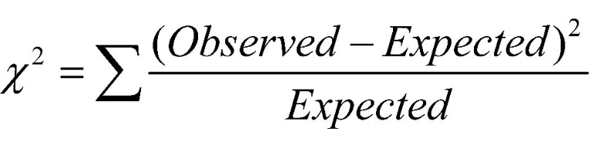

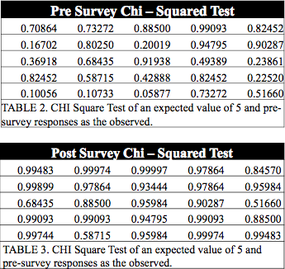

IX. Results
The results of data gathered from the pre-survey and post-survey instruments were used to determine whether or not the information conveyed during the workshop produced any changes in parents’ attitudes toward homework assistance Kindergarten through 2nd grade mathematics and involvement in school instructional activities. The graph scales was determined by calculating a perfect 5 on the likert scale and multiplying this level to the number of questions in the pre survey and post survey and lastly multiplying the total number of parent participants, giving a total level agreement to 1000. This scale was divided into groups pertaining to the number of questions in respect to the main three focus questions.

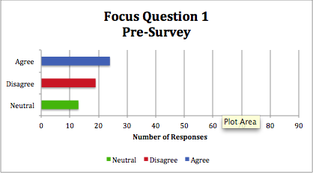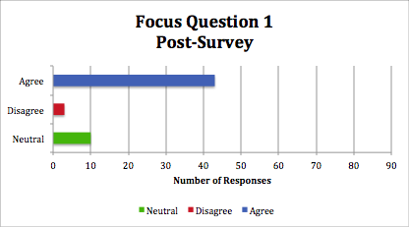
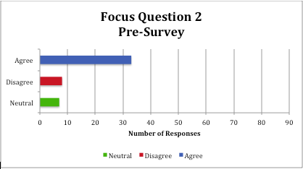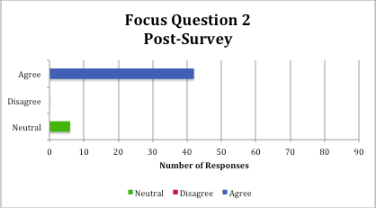
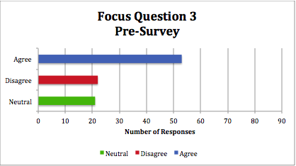

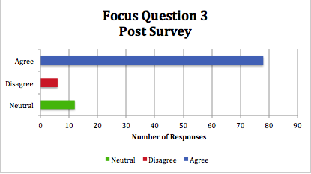
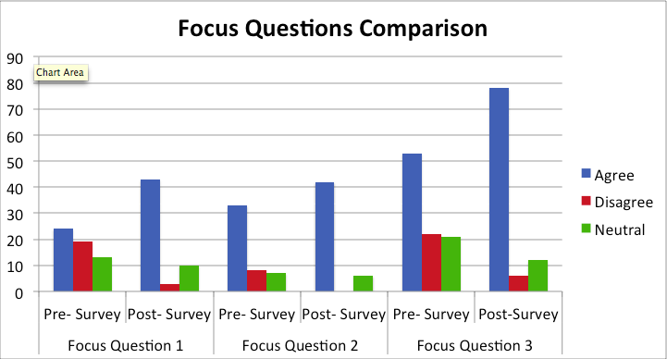

X. Conclusion
The results of the surveys concluded that Parent Involvement contributes to growth in student learning. Involved parents accomplish things, including motivating and engaging their children, acquiring new knowledge and skills, and collaborating with teachers. But those accomplishments best serve their purpose when they lead their children to help improve student achievement. The workshop provided richer information on what skills and topics students are learning according to the North Carolina Common Core State Standards. Assisting parents in an understanding of the standards provided the parents with a different perspective on mathematics and the importance of being involved with their child’s education. Parents understood the math language by constructing different activities and were given different tips that can be used in the home during the workshops. Take-home activities and tips given in the parent tool kits benefited parents in assisting with student homework and learning. Most education reformers agree that improving student learning defines effective teaching. The best way to enhance parent involvement is to provide parents with guidance that is grounded in the standards and school—that is, parent use involvement to encourage student learning [10].

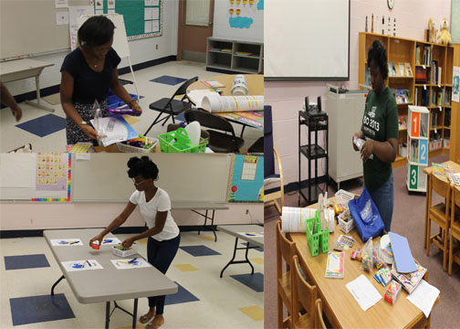

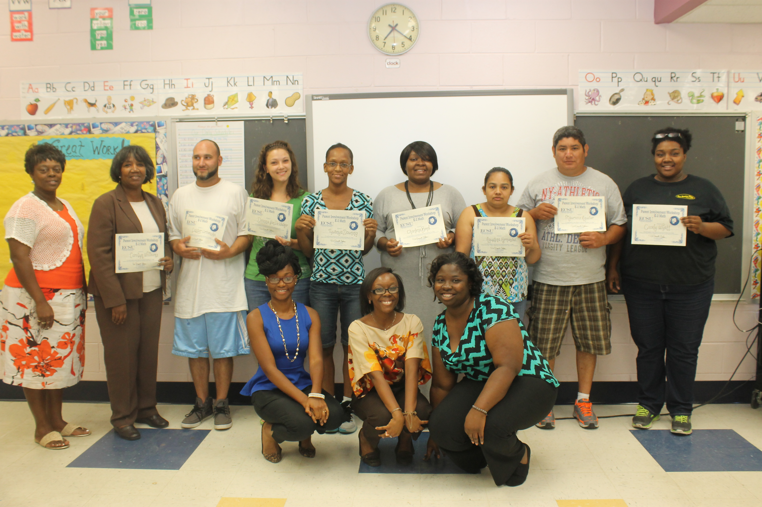

Future Work
The long-term goal is to build stronger parent support systems in Kindergarten, 1st grade, and 2nd grade Mathematics in Pasquotank County Public Schools using the North Carolina Common Core State Standards. Continuation of this parent involvement workshop will be conducted at P. W. Elementary School during the 2014 – 2015 academic school year. Using the same research methods, attendance in the workshops will be enhanced by greater assistance by classroom teachers soliciting parents of Kindergarten through 2nd grade levels.
Acknowledgements
The members of the 2014 Research Undergraduates Mathematics Team would like to give a special thanks to Dr. Linda B. Hayden, Dr. Darnell Johnson, Dr. Ervin Howard, Dr. Stephanie D. B. Johnson, Principal Lindsey James, 2014 Teacher of the Year Mrs. Joycelyn Hinton, Michael Jefferson Jr., the REU Staff, and staff of P.W. Moore Elementary School for guidance and assistance during this research process.
References

- All In. (2014). WHAT IS CURRICULUM ALIGNMENT AND WHY DOES IT MATTER? [Online]. Available: http://allinbrownsville.org/educators/curriculum-alignment/what-is-curriculum-alignment-and-why-does-it-matter/
- Common Core State Standards Initiative. (2014). Mathematics Standards [Online]. Available: http://www.corestandards.org/Math/
- Council of the Great City Schools. (2014). Parent Roadmaps to Common Core Standards [Online]. Available: http://www.cgcs.org/Page/1
- D. Squires, “Curriculum Alignment Research Suggests That Alignment Can Improve Student Achievement,” in The Clearing House: A Journal of Educational Strategies, Issues and Ideas, vol 85, Connecticut State University, New Haven CT. 2012, pp. 129-135.
- District Administration. (2004, July). The Benefits of Curriculum Alignment [Online]. Available: http://www.districtadministration.com/article/benefits-curriculum-alignment
- Education Place. (1997). Why Is It Important to Align Instruction and Assessment? [Online]. Available: http://www.eduplace.com/rdg/res/litass/align.html
- F. Hess. (2013, February 28). Straight Up Conversation: Common Core Guru Jason Zimba [Online]. Available: http://educationnext.org/straight-up-conversation-common-core-guru-jason-zimba/
- J. Cook. (2014). What are the Benefits of Curriculum Alignment? [Online]. Available: http://www.ehow.com/list_6385087_benefits-curriculum-alignment_.html
- L. Ferlazzo. (2012, March 27). The Difference Between Parent “Involvement” & Parent “Engagement”[Online]. Available: http://blogs.edweek.org/teachers/classroom_qa_with_larry_ferlazzo/2012/03/response_the_difference_between_parent_involvement_parent_engagement.html
- Michigan Department of Education (2001). WHAT RESEARCH SAYS ABOUT PARENT INVOLVEMENT IN CHILDREN’S EDUCATION In Relation to Academic Achievement [Online]. Available: http://www.michigan.gov/documents/Final_Parent_Involvement_Fact_Sheet_14732_7.pdf
- NCTM. (2014). Working With Your Child’s School [Online]. Available: http://www.nctm.org/resources/content.aspx?id=2796
- North Carolina Department of Public Instruction. (2014). NC Math Common Core – Elementary [Online]. Available: http://maccss.ncdpi.wikispaces.net/Elementary
- Oscar J. Pope Elementary School. (2013). Parent Involvement [Online]. Available: http://schools.polk-fl.net/ojp/parentinvolvement.htm
- W. H. Jeynes. (2005, April 2005), A Meta-Analysis of the Relation of Parental Involvement to Urban Elementary School Student Academic Achievement [Online]. Available: http://uex.sagepub.com/content/40/3/237

